Multiclass Logistic Regression
mathematics of multiclass logistic regression
Google:
Multiclass logistic regression (also known as softmax regression or multinomial logistic regression) extends binary logistic regression to classify data points into one of K mutually exclusive categories (\(k \in \{1, 2, \dots, K\}\)). [1, 2, 3, 4]
You can read a detailed technical derivation on Wikipedia's Multinomial Logistic Regression page. [1]

1. Linear Score / Logit Calculation
For an input feature vector \(\mathbf{x} \in \mathbb{R}^M\) (including a bias/intercept term), the model computes a raw linear score (logit) \(z_{k}\) for each class k:
\(z_{k}=\mathbf{w}_{k}^{T}\mathbf{x}+b_{k}\)
Or in matrix form across all K classes:
\(\mathbf{z}=\mathbf{W}^{T}\mathbf{x}+\mathbf{b}\)
- \(\mathbf{W} \in \mathbb{R}^{M \times K}\) is the weight matrix.
- \(\mathbf{b} \in \mathbb{R}^K\) is the bias vector.

2. The Softmax Function
To convert the raw logits \(\mathbf{z} = [z_1, z_2, \dots, z_K]^T\) into a valid probability distribution where all class probabilities are positive and sum to 1, the model applies the softmax function: [1, 2]
\(P(y=k\mid \mathbf{x};\mathbf{W})=\sigma (\mathbf{z})_{k}=\frac{e^{z_{k}}}{\sum _{j=1}^{K}e^{z_{j}}}=\frac{e^{\mathbf{w}_{k}^{T}\mathbf{x}}}{\sum _{j=1}^{K}e^{\mathbf{w}_{j}^{T}\mathbf{x}}}\)
- Properties:
  - \(\sum_{k=1}^K P(y = k \mid \mathbf{x}) = 1\)
  - \(P(y = k \mid \mathbf{x}) \in (0, 1)\) for all k
  - Prediction rule: The predicted class is the one with the maximum estimated probability (\(\arg\max_k P(y = k \mid \mathbf{x})\)). [1, 2, 3]

3. Loss Function: Cross-Entropy (Negative Log-Likelihood)
Given a dataset of N independent samples \(\{(\mathbf{x}_i, \mathbf{y}_i)\}_{i=1}^N\), where \(\mathbf{y}_{i}\) is a one-hot encoded vector of shape K × 1 (with \(y_{i,k} = 1\) if sample i belongs to class k, and 0 otherwise), the total loss is the multiclass cross-entropy loss (negative log-likelihood): [1, 2]
\(J(\mathbf{W})=-\frac{1}{N}\sum _{i=1}^{N}\sum _{k=1}^{K}y_{i,k}\log P(y_{i}=k\mid \mathbf{x}_{i};\mathbf{W})\)
You can explore a Python implementation breakdown via the Sophia Yang TDS Architecture Guide. [1]

4. Gradient and Optimization
To minimize the loss function \(J(\mathbf{W})\), we compute the partial derivative (gradient) with respect to the weights \(\mathbf{W}\).
For a single sample \(\mathbf{x}_{i}\) with predicted probabilities \(\mathbf{p}_i = [\hat{y}_{i,1}, \hat{y}_{i,2}, \dots, \hat{y}_{i,K}]^T\) and true one-hot label \(\mathbf{y}_{i}\), the derivative of the cross-entropy loss simplifies remarkably:
\(\frac{\partial J_{i}}{\partial \mathbf{w}_{k}}=(\^{y}_{i,k}-y_{i,k})\mathbf{x}_{i}\)
- Vectorized gradient for class k across all N samples:
\(\nabla _{\mathbf{w}_{k}}J=\frac{1}{N}\mathbf{X}^{T}(\^{\mathbf{y}}_{k}-\mathbf{y}_{k})\)
- Optimization methods: Because the objective function is convex, the parameters are typically optimized using gradient descent, L-BFGS, Newton-Raphson, or Fisher scoring. [1]
Would you like to see:
A Python code snippet using NumPy to build multiclass logistic regression from scratch?A breakdown of regularization (L₁ / L₂) in this formulation?The derivation of why the softmax gradient simplifies to \((\hat{y} - y)\)?

Plot Multinomial and One-vs-Rest Logistic Regression in Scikit Learn
https://www.geeksforgeeks.org/python/plot-multinomial-and-one-vs-rest-logistic-regression-in-scikit-learn/
Last Updated : 23 Jul, 2025

Logistic Regression is a popular classification algorithm that is used to predict the probability of a binary or multi-class target variable. In scikit-learn, there are two types of logistic regression algorithms: Multinomial logistic regression and One-vs-Rest logistic regression. Multinomial logistic regression is used when the target variable has more than two classes, while One-vs-Rest logistic regression is used when the target variable has two or more classes.
- Multinomial Logistic Regression: It is a logistic regression algorithm that is used when the target variable has more than two classes. It predicts the probability of each class and selects the class with the highest probability as the predicted class.
- One-vs-Rest Logistic Regression: It is a logistic regression algorithm that is used when the target variable has two or more classes. It trains one logistic regression model for each class, with that class as the positive class and all other classes as the negative class. It predicts the probability of each class and selects the class with the highest probability as the predicted class.
Multinomial and One-vs-Rest Logistic Regression
Here's an example code that demonstrates how to plot Multinomial and One-vs-Rest logistic regression models in scikit-learn using the Iris dataset:
# import libraries
from sklearn.datasets import load_iris
from sklearn.model_selection import train_test_split
from sklearn.linear_model import LogisticRegression
from sklearn.metrics import accuracy_score, confusion_matrix
import matplotlib.pyplot as plt
import numpy as np

# load the iris dataset
iris = load_iris()
X = iris.data
y = iris.target

# split the data into training and testing sets
X_train, X_test,\
y_train, y_test = train_test_split(X, y,
test_size=0.2,
random_state=42)

# create a Multinomial logistic regression model
multi_logreg = LogisticRegression(multi_class='multinomial',
solver='lbfgs')
multi_logreg.fit(X_train, y_train)

# create a One-vs-Rest logistic regression model
ovr_logreg = LogisticRegression(multi_class='ovr',
solver='liblinear')
ovr_logreg.fit(X_train, y_train)

# make predictions using the trained models
y_pred_multi = multi_logreg.predict(X_test)
y_pred_ovr = ovr_logreg.predict(X_test)

# evaluate the performance of the models
# using accuracy score and confusion matrix
print('Multinomial logistic regression accuracy:',
accuracy_score(y_test, y_pred_multi))
print('One-vs-Rest logistic regression accuracy:',
accuracy_score(y_test, y_pred_ovr))

conf_mat_multi = confusion_matrix(y_test, y_pred_multi)
conf_mat_ovr = confusion_matrix(y_test, y_pred_ovr)

# plot the confusion matrices
fig, axs = plt.subplots(ncols=2, figsize=(10, 5))
axs[0].imshow(conf_mat_multi, cmap=plt.cm.Blues)
axs[0].set_title('Multinomial logistic regression')
axs[0].set_xlabel('Predicted labels')
axs[0].set_ylabel('True labels')
axs[0].set_xticks(np.arange(len(iris.target_names)))
axs[0].set_xticklabels(iris.target_names)
axs[0].set_yticklabels(iris.target_names)
axs[1].imshow(conf_mat_ovr, cmap=plt.cm.Blues)
axs[1].set_title('One-vs-Rest logistic regression')
axs[1].set_xlabel('Predicted labels')
axs[1].set_ylabel('True labels')
axs[1].set_xticks(np.arange(len(iris.target_names)))
axs[1].set_xticklabels(iris.target_names)
axs[1].set_yticks(np.arange(len(iris.target_names)))
axs[1].set_yticklabels(iris.target_names)
plt.show()
Output:
Multinomial logistic regression accuracy: 1.0
One-vs-Rest logistic regression accuracy: 1.0
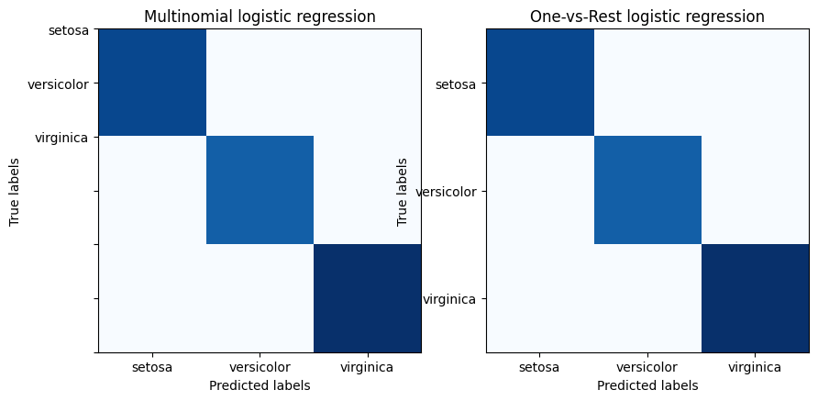Confusion Matrix for Multinomial and One-vs-Rest Logistic Regression
Multinomial Logistic Regression Plot
For the iris dataset, we will use scikit-learn library in Python to load the dataset and fit the logistic regression model. Then we will use the Matplotlib library to plot the decision boundaries which are obtained by using the Multinomial Logistic Regression.
import numpy as np
import matplotlib.pyplot as plt
from sklearn.datasets import load_iris
from sklearn.linear_model import LogisticRegression

# Load the iris dataset
iris = load_iris()

# Extract the features and target
X = iris.data[:, :2]
y = iris.target

# Create an instance of Logistic Regression classifier
clf = LogisticRegression(random_state=0,
multi_class='multinomial',
solver='newton-cg')

# Fit the model
clf.fit(X, y)

# Plot the decision boundaries
x_min, x_max = X[:, 0].min() - .5, X[:, 0].max() + .5
y_min, y_max = X[:, 1].min() - .5, X[:, 1].max() + .5
xx, yy = np.meshgrid(np.arange(x_min, x_max, .02),
np.arange(y_min, y_max, .02))
Z = clf.predict(np.c_[xx.ravel(), yy.ravel()])
Z = Z.reshape(xx.shape)
plt.figure(1, figsize=(4, 3))
plt.pcolormesh(xx, yy, Z, cmap=plt.cm.Paired)
plt.scatter(X[:, 0], X[:, 1], c=y, edgecolors='k',
cmap=plt.cm.Paired)
plt.xlabel('Sepal length')
plt.ylabel('Sepal width')
plt.show()
Output:
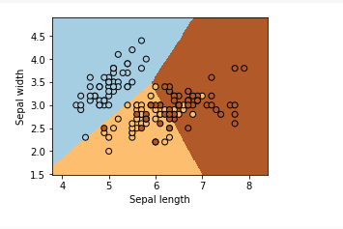Decision boundaries obtained by using the Multinomial Logistic Regression
One-vs-Rest Logistic Regression Plot
For the iris dataset, we will use scikit-learn library in Python to load the dataset and fit the logistic regression model. Then we will use Matplotlib library to plot the decision boundaries which are obtained by using the one-vs-rest Logistic Regression.
import numpy as np
import matplotlib.pyplot as plt
from sklearn.datasets import load_iris
from sklearn.linear_model import LogisticRegression

iris = load_iris()

# we only take the first two features for visualization
X = iris.data[:, :2]
y = iris.target

clf = LogisticRegression(random_state=0,
multi_class='ovr',
solver='liblinear')

clf.fit(X, y)

x_min, x_max = X[:, 0].min() - .5, X[:, 0].max() + .5
y_min, y_max = X[:, 1].min() - .5, X[:, 1].max() + .5
xx, yy = np.meshgrid(np.arange(x_min, x_max, .02),
np.arange(y_min, y_max, .02))
Z = clf.predict(np.c_[xx.ravel(), yy.ravel()])
Z = Z.reshape(xx.shape)
plt.figure(1, figsize=(4, 3))
plt.pcolormesh(xx, yy, Z, cmap=plt.cm.Paired)
plt.scatter(X[:, 0], X[:, 1], c=y, edgecolors='k',
cmap=plt.cm.Paired)
plt.xlabel('Sepal length')
plt.ylabel('Sepal width')
plt.title('One-vs-Rest logistic regression')
plt.show()
Output:
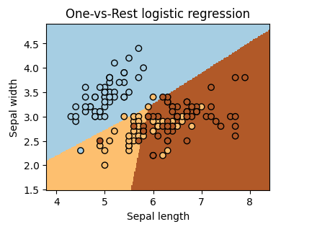Decision boundaries obtained by using the One-vs-Rest Method
In conclusion, we have demonstrated how to implement Multinomial and One-vs-Rest logistic regression models in scikit-learn for multi-class classification problems. We have shown how to train and evaluate the models and how to visualize the performance using a confusion matrix. These models can be useful for a variety of applications where the target variable has multiple classes.

sklearn train_test_split stratify
Google:

In scikit-learn's train_test_split, the stratify parameter ensures that the training and testing datasets maintain the exact same proportion of class labels as the original dataset. [1, 2]
Without stratification, a standard random split might drastically alter the class distribution or accidentally leave out rare classes entirely from either the training or test set. This is essential when working with imbalanced datasets (e.g., fraud detection or rare disease diagnosis). [1, 2, 3]
Standard Implementation
To use it, you pass your target array (usually y) to the stratify parameter: [1, 2]
python
from sklearn.model_selection import train_test_split

# Split your data while preserving the class distribution of 'y'
X_train, X_test, y_train, y_test = train_test_split(
X, y,
test_size=0.25,
random_state=42,
stratify=y
)
Use code with caution.
Visual Example: How It Works
Imagine you have a dataset with 100 samples, where 80 are "Legit" and 20 are "Fraud" (an 80:20 ratio). If you perform a 50/50 train-test split: [1]
Split Type | Training Set Distribution (50 samples) | Testing Set Distribution (50 samples)
Without Stratification  (Purely Random) | Can easily become skewed by chance:  • 45 Legit  • 5 Fraud | • 35 Legit  • 15 Fraud
With Stratification  (Using stratify=y) | Guaranteed 80:20 ratio:  • 40 Legit (80%)  • 10 Fraud (20%) | Guaranteed 80:20 ratio:  • 40 Legit (80%)  • 10 Fraud (20%)
Why This Matters
- Prevents Data Omission: It ensures your model actually sees the minority class during training. [1, 2]
- Realistic Evaluation: It ensures the test set mimics the true distribution, making metrics like Precision, Recall, and F1-score highly reliable. [1]
- Rule Check: Keep in mind that stratify only works when shuffle=True (which is the default). [1]
If you are dealing with a specific type of data, let me know:
- Is your dataset highly imbalanced (e.g., 99% vs 1%)?
- Are you trying to stratify on multiple columns or a continuous regression target?
I can provide the right advanced code snippet or cross-validation strategy for your setup.

Can you explain cross-validation strategy
Google:

Cross-validation (CV) is a resampling technique used to evaluate how well a machine learning model generalizes to unseen data.
Instead of relying on a single, fixed split of training and testing data—which can lead to overly optimistic or lucky results—cross-validation systematically splits the dataset multiple times. This ensures that every single data point is used for both training and testing at least once, giving you a highly reliable estimate of your model's true performance.

🧱 The Standard: K-Fold Cross-Validation
The most common strategy is K-Fold Cross-Validation.
- Split: The entire dataset is divided into \(K\) equal-sized chunks (called "folds").
- Loop: The model runs \(K\) times. In each iteration, a different fold serves as the test set, while the remaining \(K-1\) folds are combined to form the training set.
- Average: The performance metrics (e.g., accuracy, F1-score) from all \(K\) rounds are averaged together.
Visualizing a 5-Fold Cross-Validation (K=5)
text
Dataset: [ ████████████████████████████████████████ ]

Iteration 1: [ TEST ][ train ][ train ][ train ][ train ] -> Score 1
Iteration 2: [ train ][ TEST ][ train ][ train ][ train ] -> Score 2
Iteration 3: [ train ][ train ][ TEST ][ train ][ train ] -> Score 3
Iteration 4: [ train ][ train ][ train ][ TEST ][ train ] -> Score 4
Iteration 5: [ train ][ train ][ train ][ train ][ TEST ] -> Score 5

Final Result = Average(Score 1, Score 2, Score 3, Score 4, Score 5)
Use code with caution.

🛠️ Choosing the Right CV Strategy
Different types of data require different splitting rules to prevent data leakage and biased results.
Strategy | When to Use | How It Works | Scikit-Learn Class
K-Fold | Balanced, independent data. | Splits data randomly into \(K\) parts. | KFold
Stratified K-Fold | Imbalanced classification data. | Preserves the class percentage in every single fold (building on the stratify concept). | StratifiedKFold
Time Series Split | Chronological data (stock prices, weather forecasts). | Uses a "rolling window" approach. It never uses future data to predict past data. | TimeSeriesSplit
Group K-Fold | Clustered/grouped data (e.g., multiple medical scans from the same patient). | Ensures the same group never appears in both training and testing folds, preventing overfitting to individuals. | GroupKFold

💻 Standard Implementation in Python
Scikit-learn makes this straightforward using cross_val_score. Building on your previous inquiry about stratification, here is how you run a Stratified 5-Fold Cross-Validation:
python
from sklearn.model_selection import StratifiedKFold, cross_val_score
from sklearn.ensemble import RandomForestClassifier

# 1. Define the model
model = RandomForestClassifier(random_state=42)

# 2. Define the cross-validation strategy (5 folds, stratified)
cv_strategy = StratifiedKFold(n_splits=5, shuffle=True, random_state=42)

# 3. Evaluate the model automatically across all folds
scores = cross_val_score(model, X, y, cv=cv_strategy, scoring='accuracy')

print(f"Scores per fold: {scores}")
print(f"Mean Accuracy: {scores.mean():.4f} +/- {scores.std():.4f}")
Use code with caution.
To recommend the absolute best validation pipeline, let me know:
- What type of data are you working with? (e.g., tabular, time series, text)
- Are you trying to tune model hyperparameters at the same time?

